**Customer Retention**

**Case Study Report**

**Prepared by**

**Anubhav Saxena**

**Data Science Intern at Flip Robo Technologies**

Acknowledgement

Presenting this report gives me great joy and satisfaction. Working on this project was a fantastic experience that taught me a lot about data analysis. **Flip Robo Technologies** provided all of the necessary information and datasets, which aided me in finishing the project. I'd want to express my gratitude to **Shubham Yadav**, my subject matter expert, for providing the dataset and detailed directions for doing the case study.



# Introduction

**Problem Statement**

Consumer happiness has emerged as one of the most significant criteria in ensuring an online store's success; it has been identified as a primary stimulator of buy or repurchase intentions, as well as customer loyalty. To present the models for customer activation and retention, a thorough assessment of the literature, theories, and models was conducted. Service quality, system quality, information quality, trust, and net benefit were recognized as five important variables that contributed to the success of an e-commerce shop. The study also looked at the elements that impact the likelihood of repeat purchases by internet clients. To favorably influence repeat purchase intention (loyalty), a mix of utilitarian and hedonistic values is required. The information was gathered from Indian internet shoppers. The findings reveal the e-retail success characteristics that are crucial for client happiness.

The Executive Summary should be completed last, after all of the previous sections have been finished. From the Company Overview through the Financial Plan, the writing should tell the tale of the business's drive and goal as information is filled in. Include what will make the company successful, how it will be achieved, and how success will be assessed.

It's critical to maintain the business plan up to date in order to track progress, recognize successes, and make adjustments as needed. This should be done at least quarterly, if not monthly.

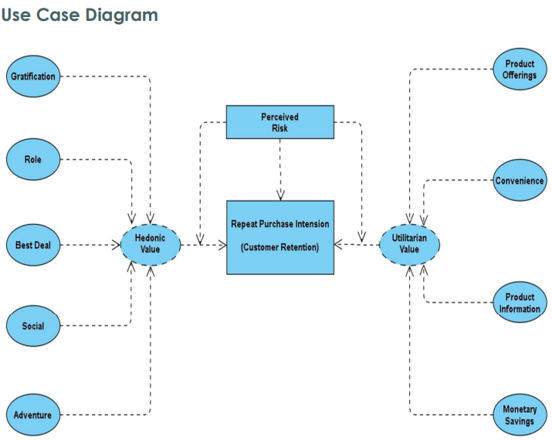

**We can see from the above use case diagram that our Customer Retention approach is based on Hedonic and Utilitarian value. We also see that our clients' buy and repurchase intentions are influenced by perceived risks. The Hedonic value consists of five primary components: satisfaction, role, best bargain, social aspect, and adventurous sensation. Product options, convenience, product knowledge, and monetary savings are all examples of utilitarian value.**

**Motivation for the Problem Undertaken**

The primary goal of this study is to determine if consumers purchase for items on e-commerce websites. How did they provide feedback to these websites based on a variety of good and negative characteristics, as well as user information such as age, gender, and location?

**Benefits of Customer Retention:**

1. Retention is cheaper than acquisition

• While the old adage about "it costs five times as much to acquire a new customer" may not be accurate in every case, the basic principle is spot on: it’s more cost-effective to keep someone in the fold than to bring in new customers.

• Even still, if it’s data you want, there has been plenty of research into acquisition vs retention, and every one of them has come back with the economics favoring retention as the more economically viable focus.

• One caveat though: retention is cheaper than acquisition, but it isn’t necessarily easier.

1. Loyal customers are more profitable

• Not only is loyalty cheaper, it has better returns. According to research, engaged consumers buy 90% more frequently, spend 60% more per transaction and are five times more likely to indicate it is the only brand they would purchase in the future.

• On average, they’re delivering 23% more revenue and profitability over the average customer.

• While loyal customers are more profitable, don’t take their loyalty for granted.

• They’ll be more open to price increases, but be cautious not to raise prices simply to see how long they’ll stick around.

• Consider the flipside: “Actively disengaged” customers (people who oppose the brand and may be actively spreading that opinion) can cost a brand 13% of its revenue.

1. Your brand will stand out from the crowd

• Put your consumer hat on, and consider how many brands you interact with that actually seem to value your patronage.

• You can probably only think of one or two.

• Most brands focus on acquisition, which makes the retentioncentric among us stand out even more.

• People see around 10,000 marketing exposures a day, but only engage with a few of them.

• The ones that earn continual engagement are those with whom they feel an emotional connection with on some level.

• Forget a unique selling proposition; the best brands have a unique retention proposition.

1. You’ll earn more word-of-mouth referrals

• Your loyal customers will be your best source of new business.

• Despite all the efforts into online and mobile marketing and social media, people are still most strongly influenced by referrals from friends and family.

• Millennials in particular will spread the word of a brand’s exploits: 90% share their brand preferences online.

1. Engaged Customers Provide More Feedback

• Feedback is critical to the success of any business.

• Customers who provide feedbacks are often willing to give brands the benefit of the doubt.

• They’re telling you how to earn their business repeatedly. As research has shown, people who have complained and seen their issue resolved are 84% less likely to decrease their spend.

• Need help dealing with the customers who are providing nasty feedback?

1. Customers will explore your brand

• That’s a nice way of saying you’ll be able to sell them more stuff.

• Once a brand has proven itself with one product or service, customers are six times more likely to say they would try a new product or service from the brand as soon as it becomes available.

• That’s not just valuable for sales, but these folks can be utilized to help with #5 above as beta testers - a critical element in product development.

1. Loyal Customers are more forgiving

• An Accenture study states over $1.6 trillion is lost each year due to customers bailing after a poor service experience.

• We've gone so far as to claim that it's the top reason people will ditch a brand.

• But customers who consider themselves loyal will let some misdeeds slide - just don't let it happen too often.

1. Customers will welcome your marketing

• No one likes being marketed to.

• Except for loyal customers!

• Those folks are four times more likely to say they “appreciate when this brand reaches out to me” and seven times more likely to “always respond to this brand’s promotional offers.”

1. You earn wiggle room to try new things

• Loyalty is fickle, so too many changes could chase people away.

• But once you’ve established a core base of proven customers, your brand can expand its boundaries.

• Maybe it’s new messaging or a new product line, or even a new logo. The bottom line is as long as you maintain the basic premises that keep people in your corner; they’ll stick with you through thin and thin.

• In fact, some of them will be excited to see what you can do.

• Existing customers are 50% more likely to try new products, according to a study.

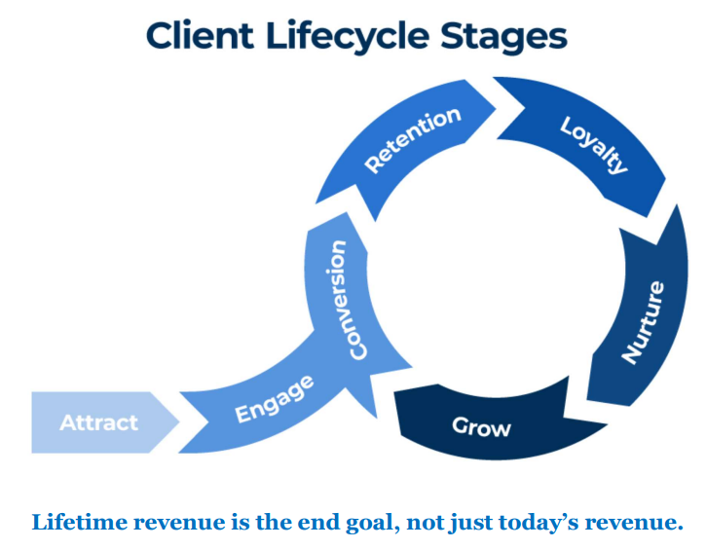

**Need for Customer Retention:**

Keeping current customers satisfied is usually less expensive than recruiting new consumers. According to the Harvard Business Review, getting a new client might cost anywhere from five to twenty-five times more than keeping an existing one.

Marketing, promotion, and sales outreach do not need to be expensive. Because they already trust your brand from prior purchases, it's simpler to convert existing consumers into repeat buyers. When it comes to the initial sale, new consumers, on the other hand, generally require more persuasion.

Customers that are loyal to a company are more likely to do business with them again. Customers that are loyal are more inclined to pass on free recommendations to their coworkers, friends, and family. One strategy for a firm to foster client loyalty for long-term success is to create that cycle of retained customers and buzz marketing.

Customer retention may be improved through enhancing the customer experience. In fact, according to a 2021 Customer Experience Trend Report, 77 percent of customers will be more loyal to a firm that provides a positive customer experience if they have a problem. 72 percent are prepared to pay more for a firm that provides excellent customer service. In addition, 50% feel that customer experience is more essential now than it was a year ago.

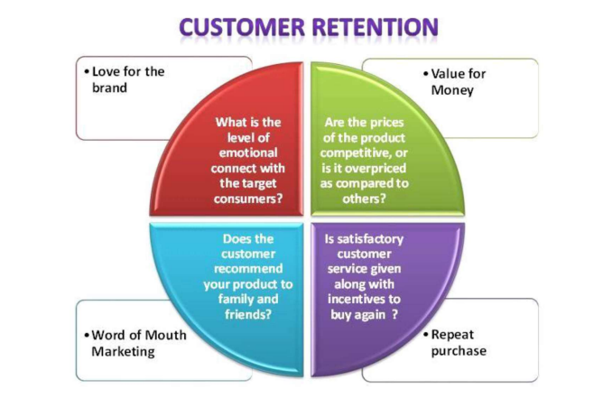

Because it costs five to ten times more to acquire a new client than it does to maintain an existing one, nurturing loyal consumers is a potent method for organizations to expand.

##### **Dataset Details:**

First, I imported all the necessary libraries and dependencies to create a detailed data analysis in Python.

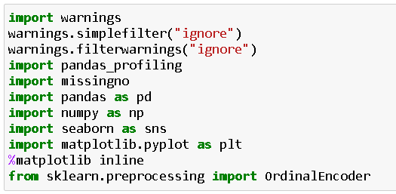

Then I separated the sheets present in our Excel spreadsheet and stored them in 2 different data frame variables.

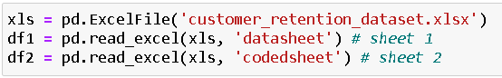

##### **Exploratory Data Analysis (EDA):**

After I got the dataset in our Jupyter Notebook I was able to notice that due to large number of rows and columns the information was truncated. Therefore, to overcome this challenge I used the pandas code as shown below.



I made sure to rename the column names that were ill formatted and quite long which made no sense to me. With the help of rename I was able to change the names of columns that were too lengthy and could have been accommodated in shorter formats.

Now was the time to take a look at any kind of missing values or null value that might have been present in our dataset.





Luckily, I was able to see that there were no missing values in our entire dataset that is prominently visible in the matrix visual below.

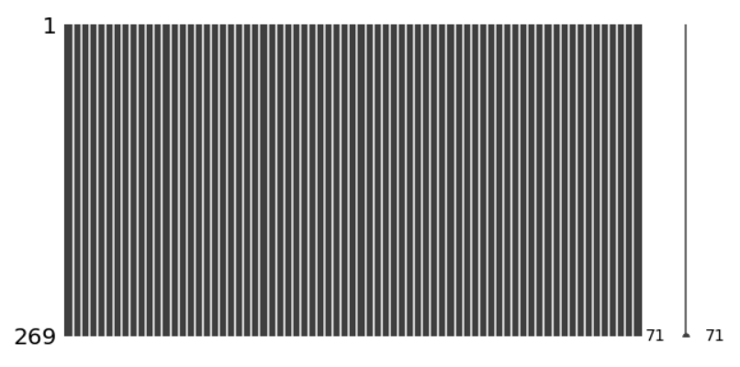

I went ahead to take a look into each record information by making use of describe, info and unique methods.

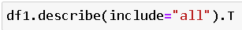





I used a for loop to take a look at all the unique values present in the categorical columns covering the number of rows in the dataset.

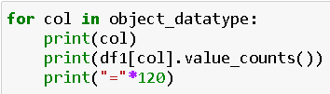

##### **Visualization:**

What is Data Visualization?

Data visualization is defined as a graphical representation that contains the information and the data.

Benefits of Good Data Visualization?

Data visualization is another technique of visual art that grabs our interest and keeps our main focus on the message captured with the help of eyes.

Different Types of Analysis for Data Visualization are:

1. Univariate Analysis: In the univariate analysis, we will be using a single feature to analyze almost all of its properties.
2. Bivariate Analysis: When we compare the data between exactly 2 features then it is known as bivariate analysis.
3. Multivariate Analysis: In the multivariate analysis, we will be comparing more than 2 variables.

**Univariate Analysis:**

I made use of 2 for loops to generate count plots for all our columns showing the percentage of data coverage.

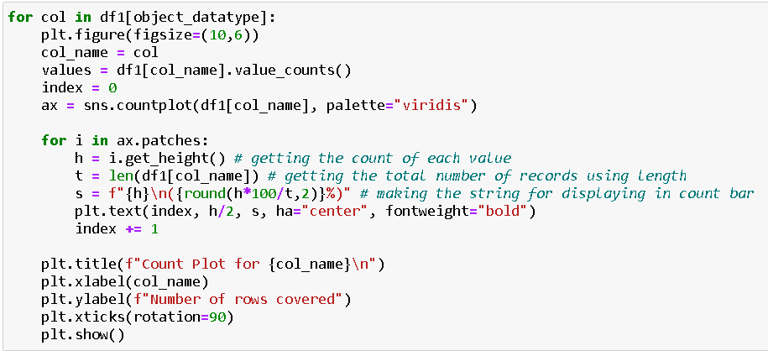

This piece of code generated multiple count plot images as displayed below.

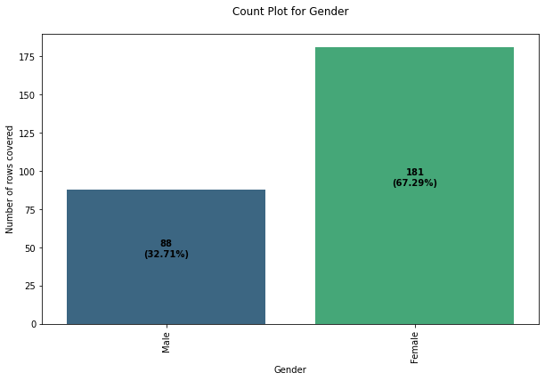

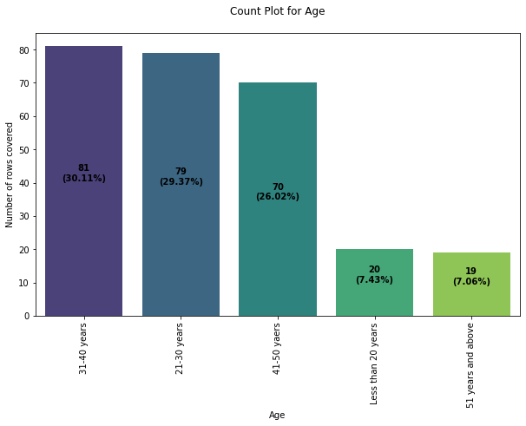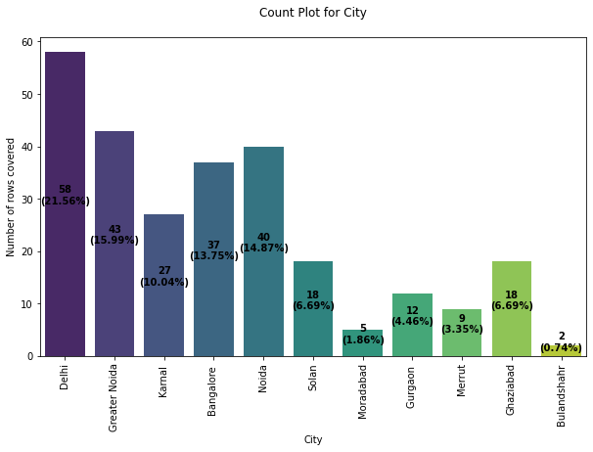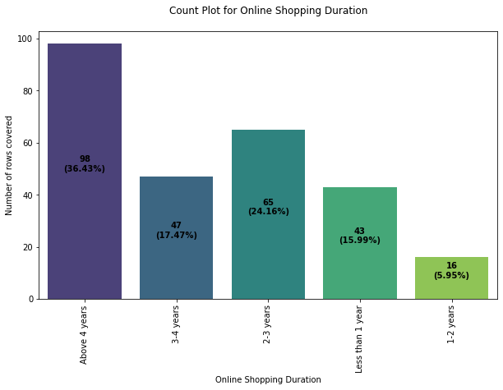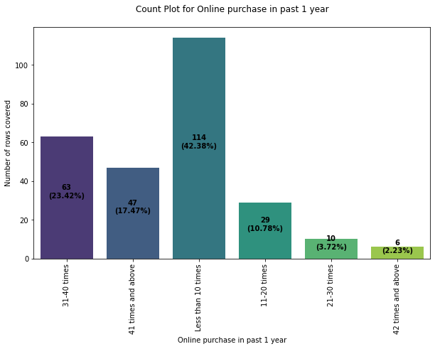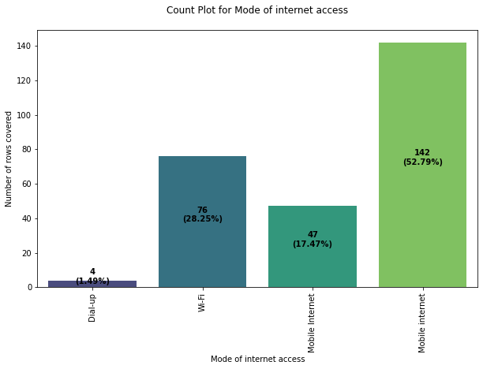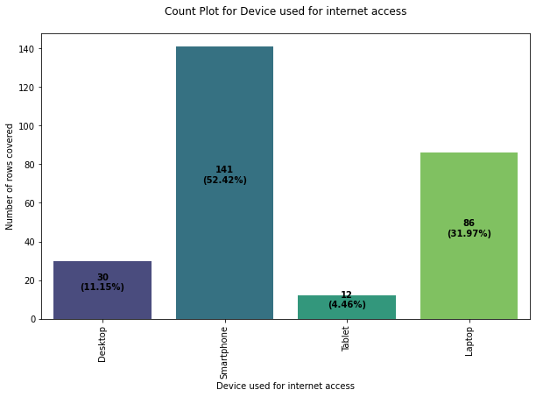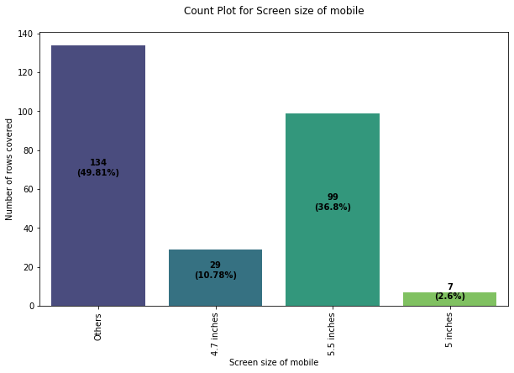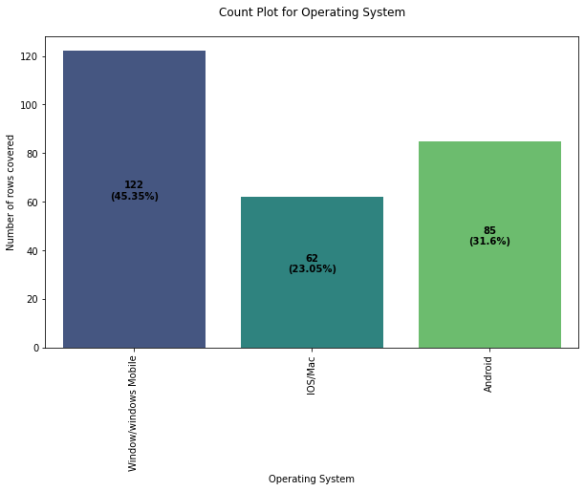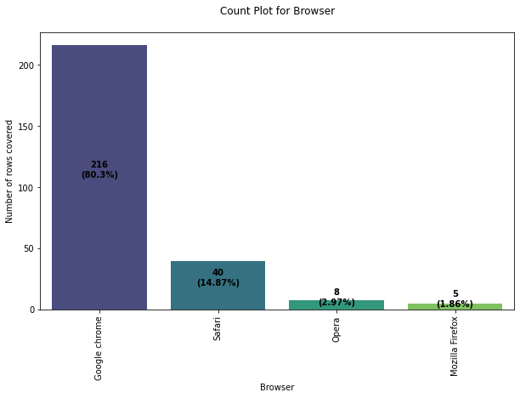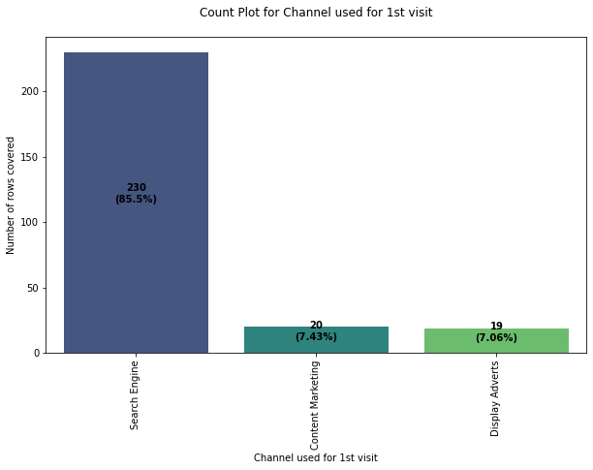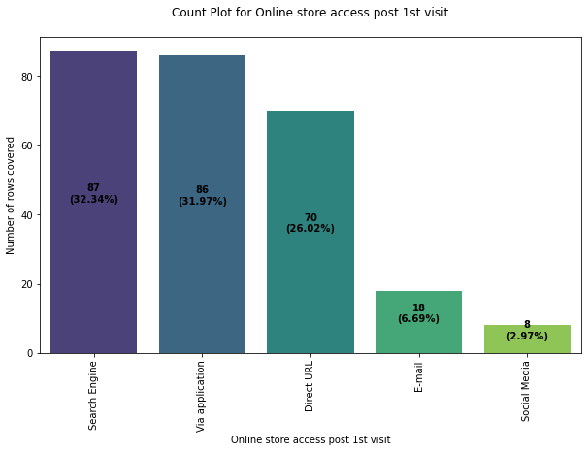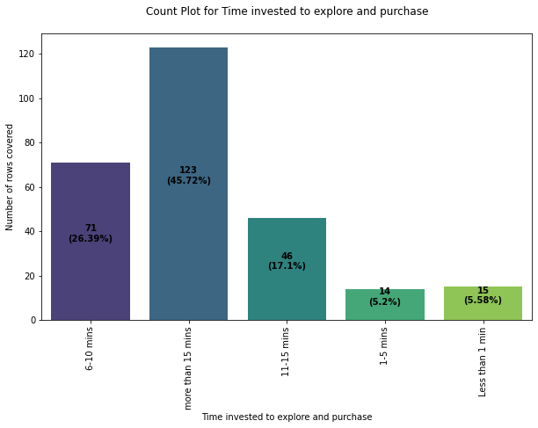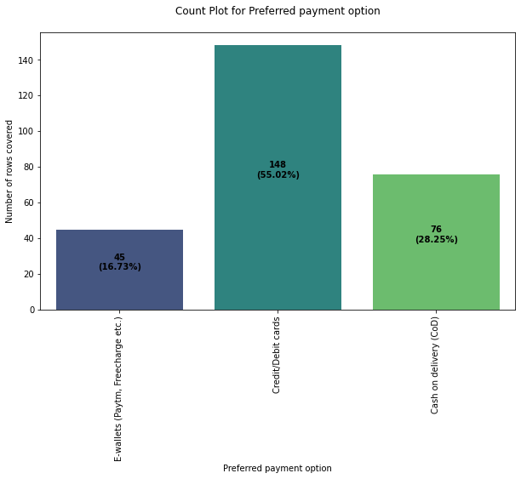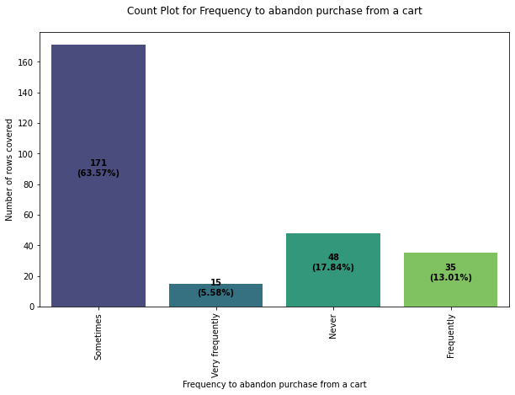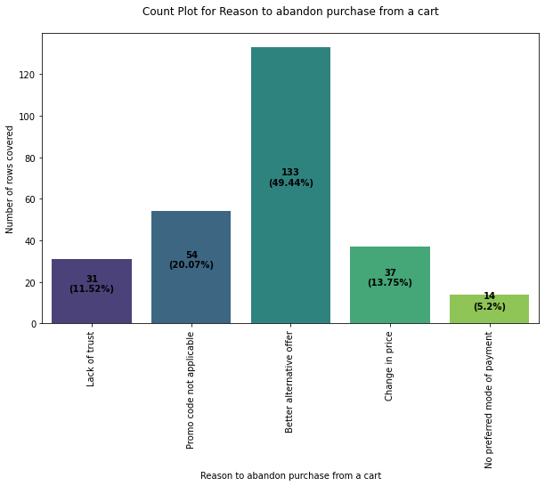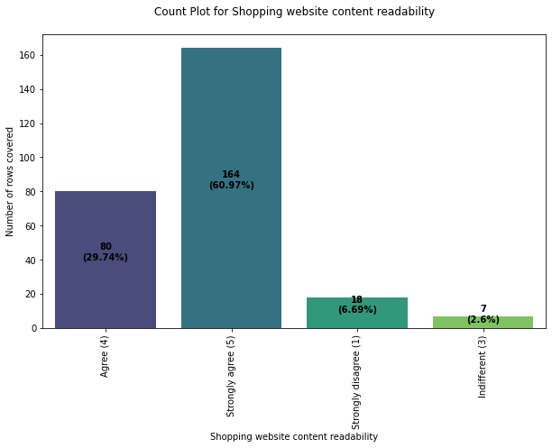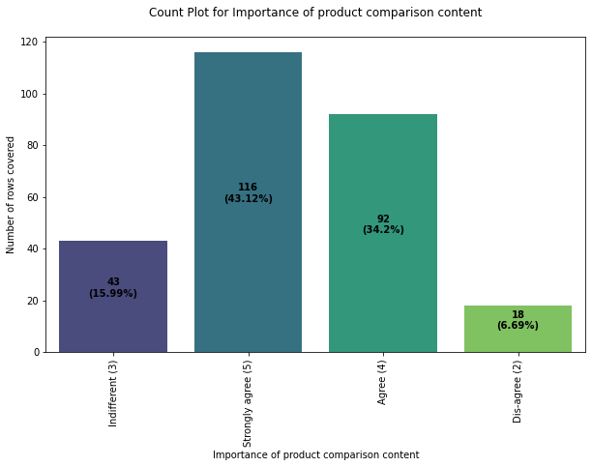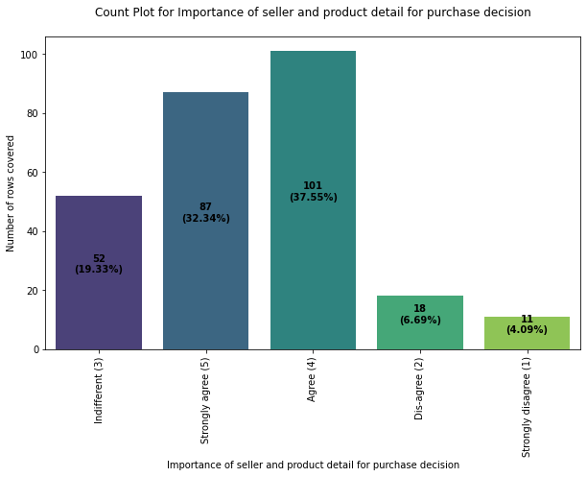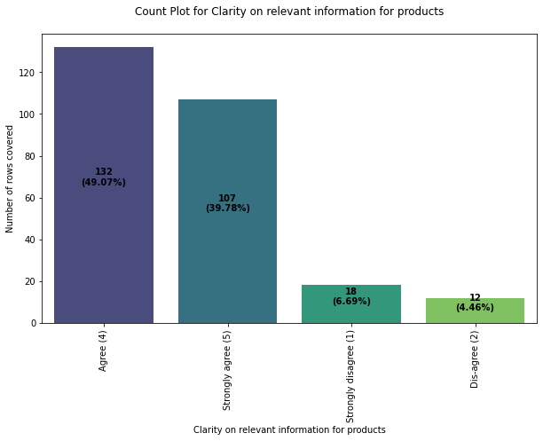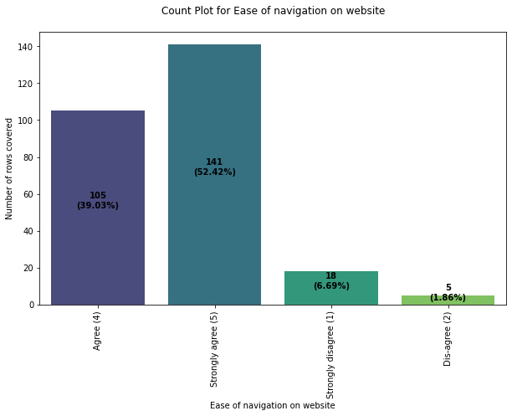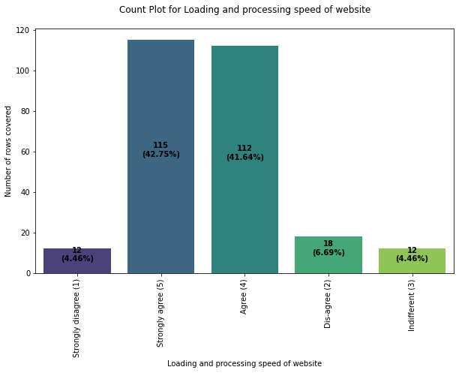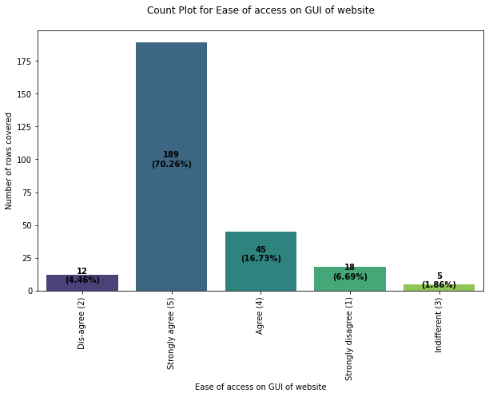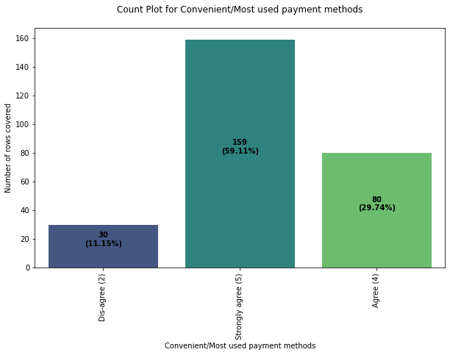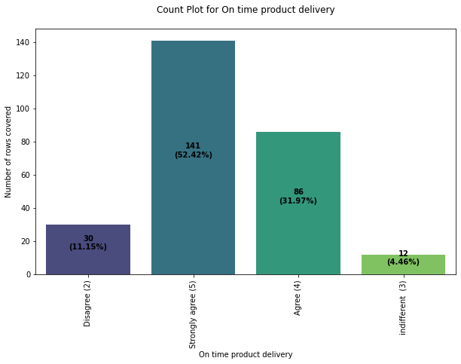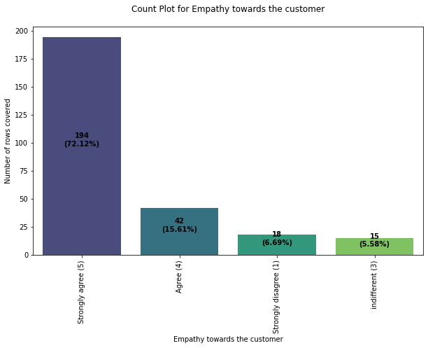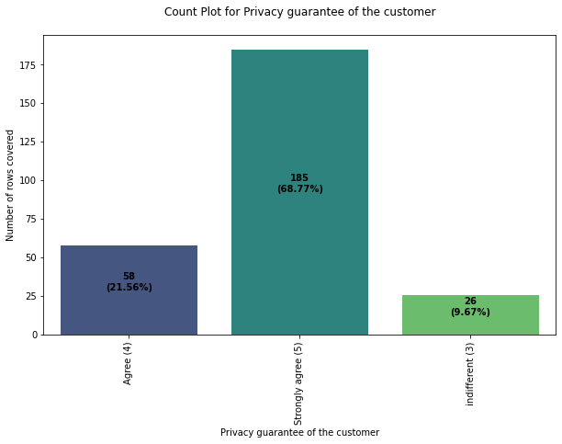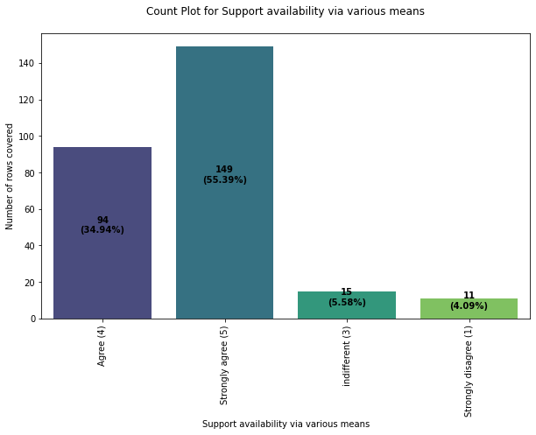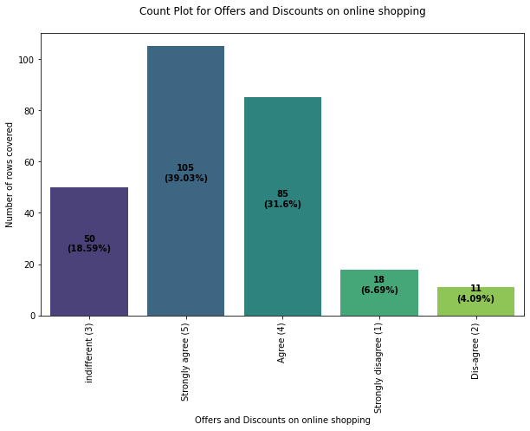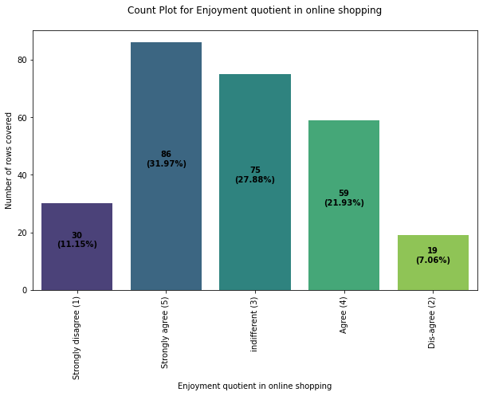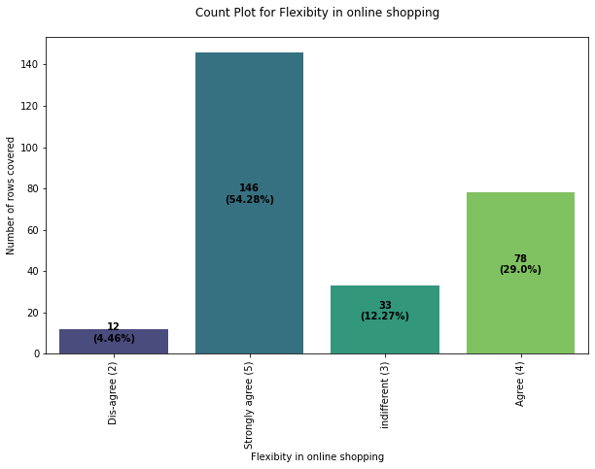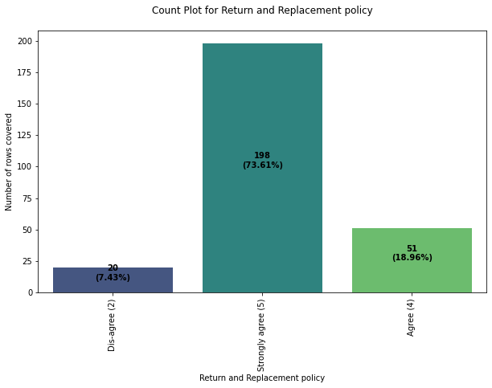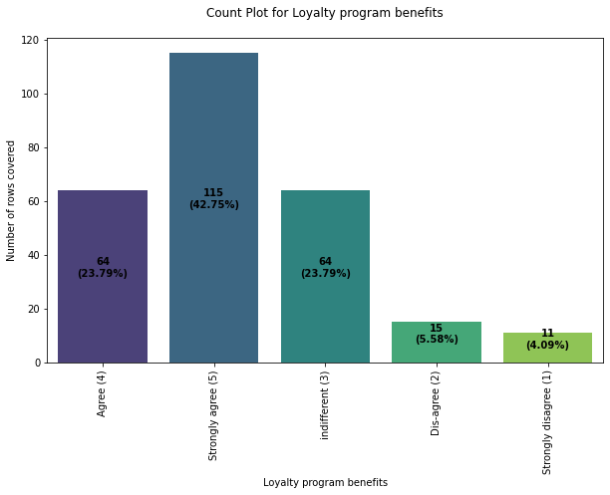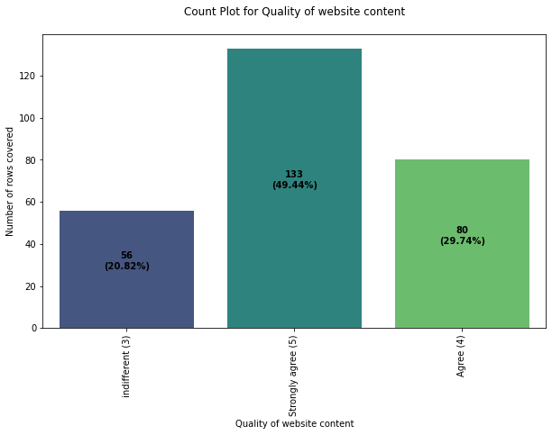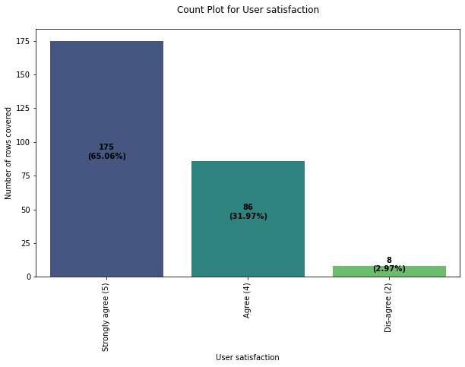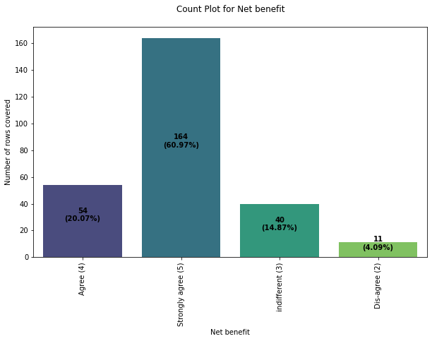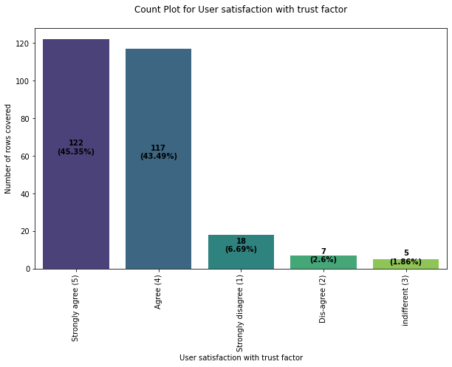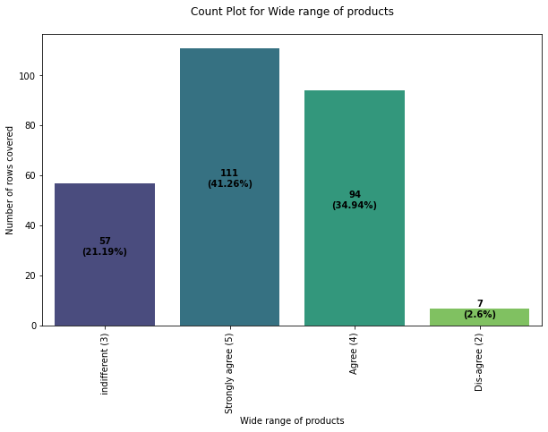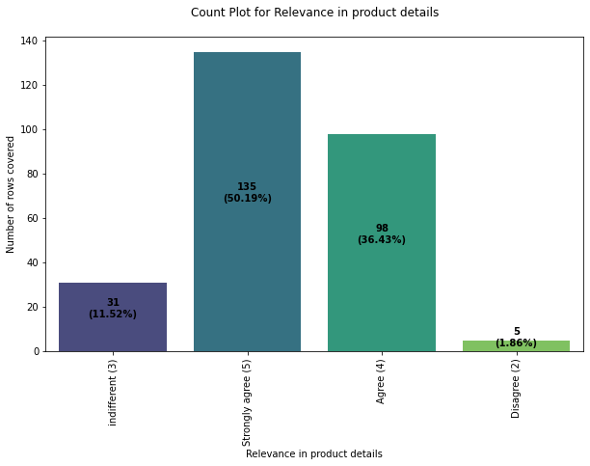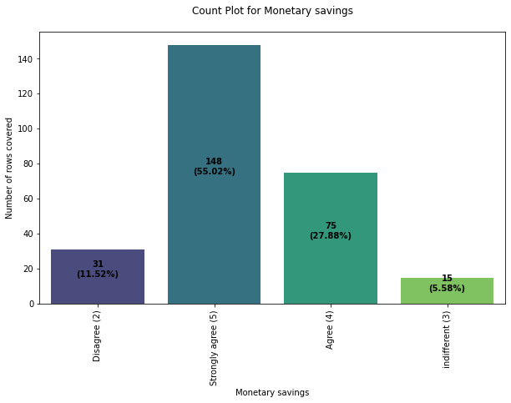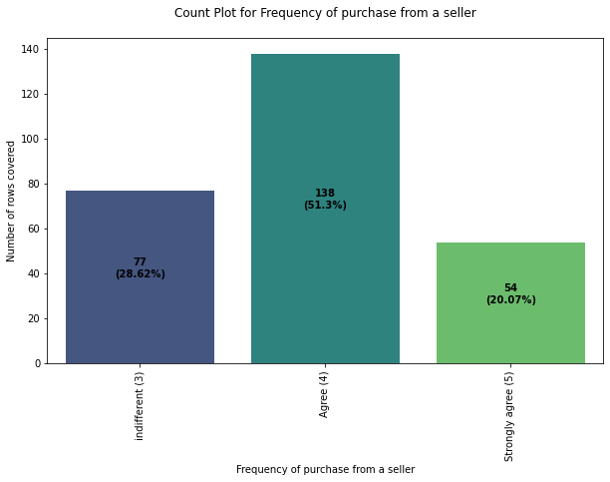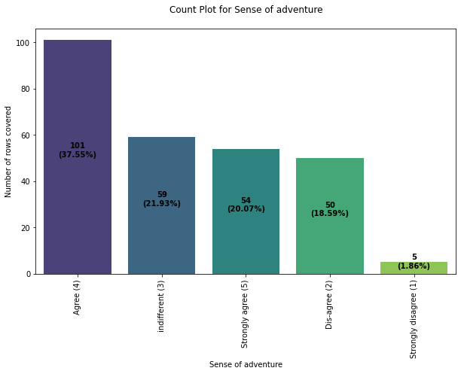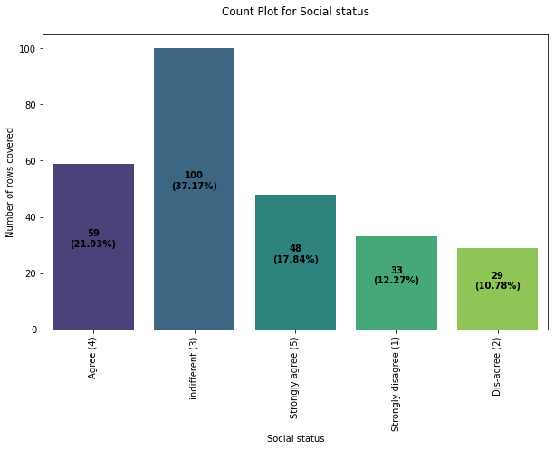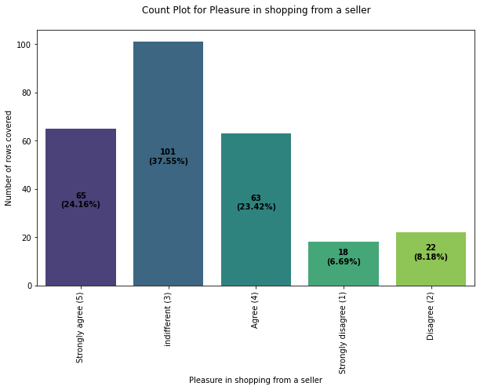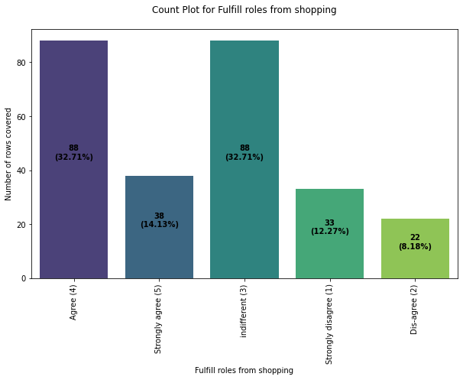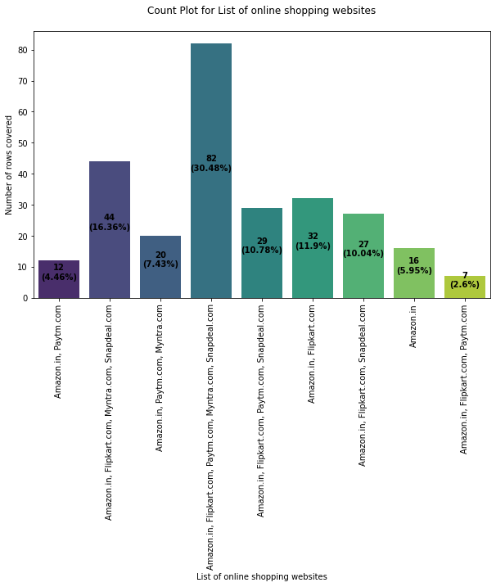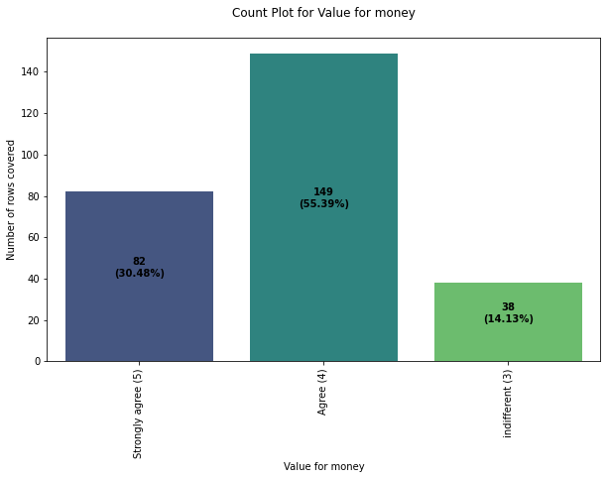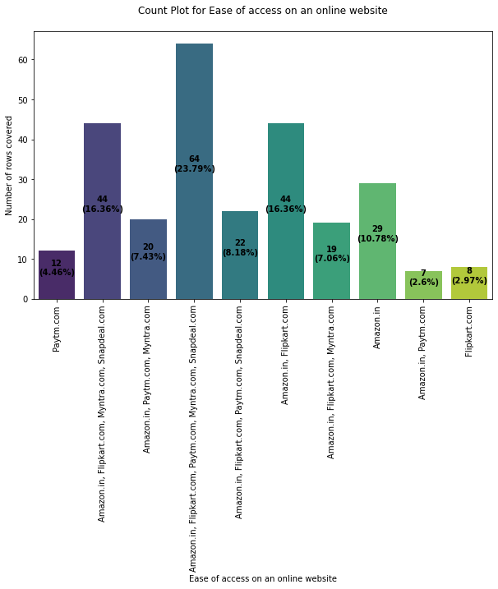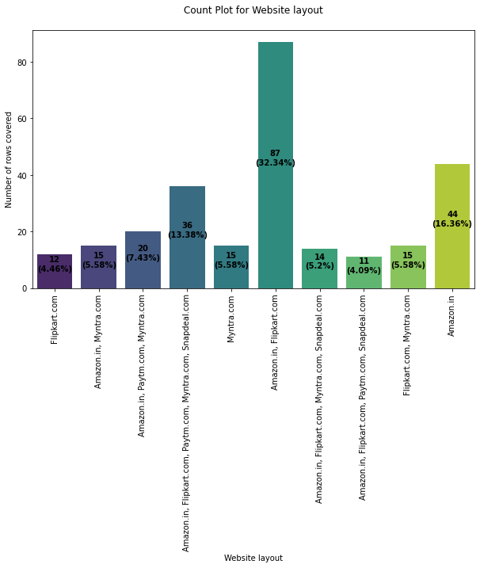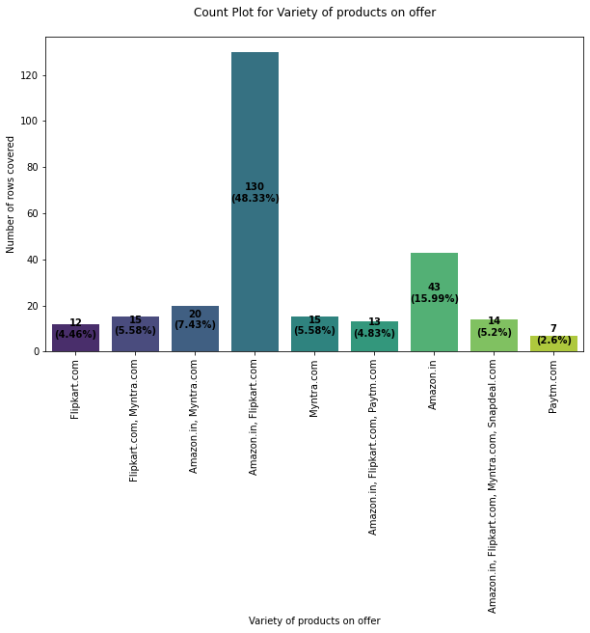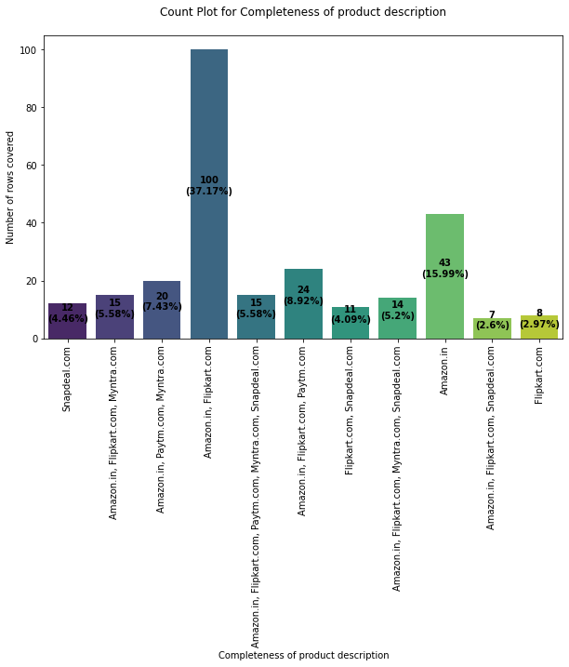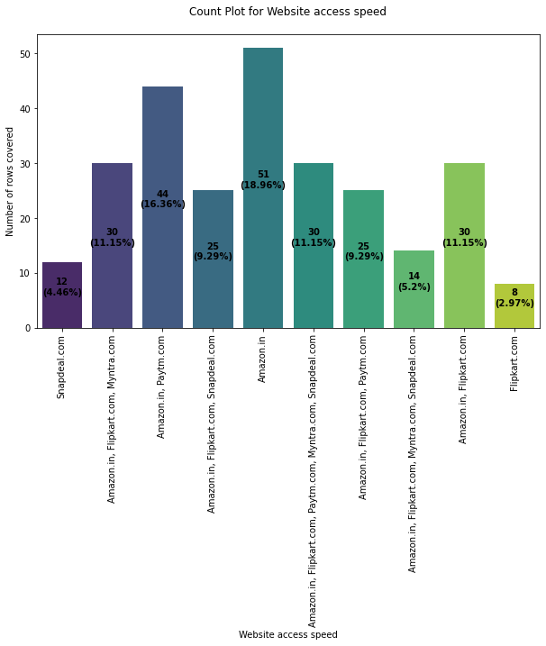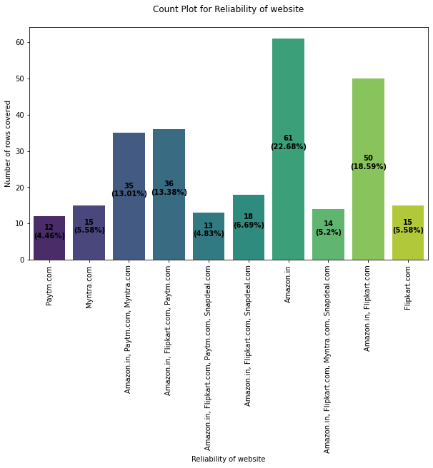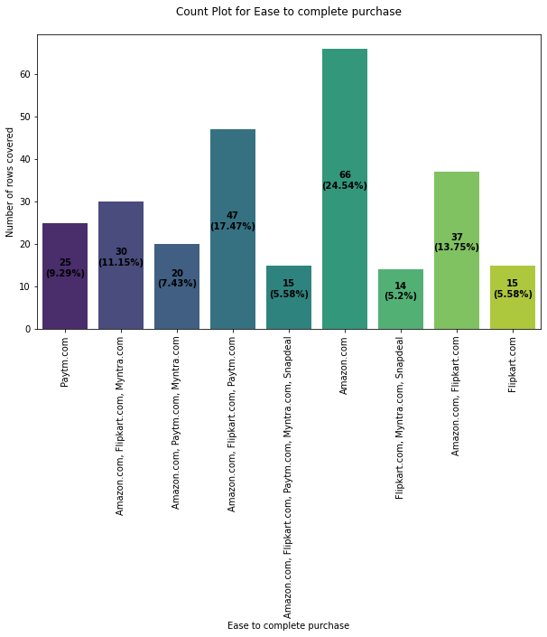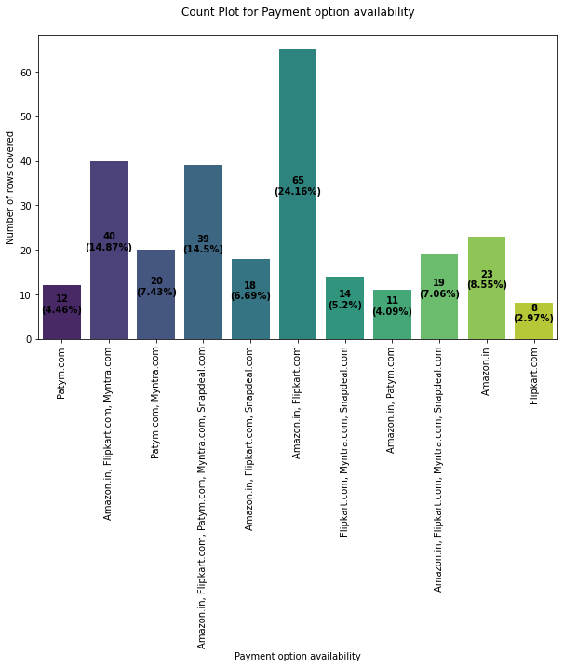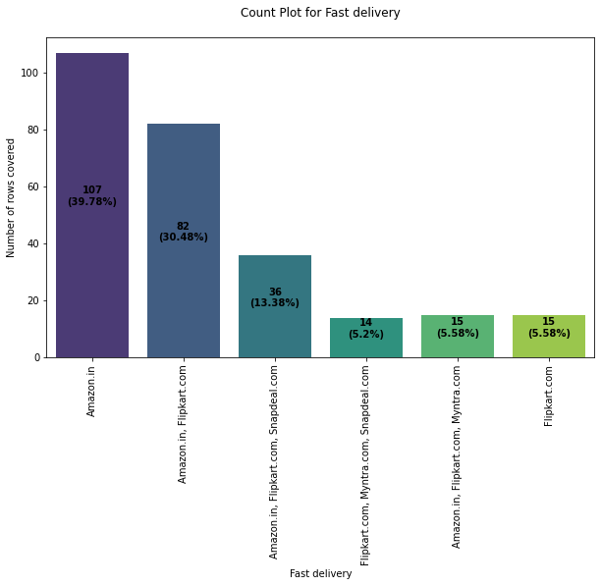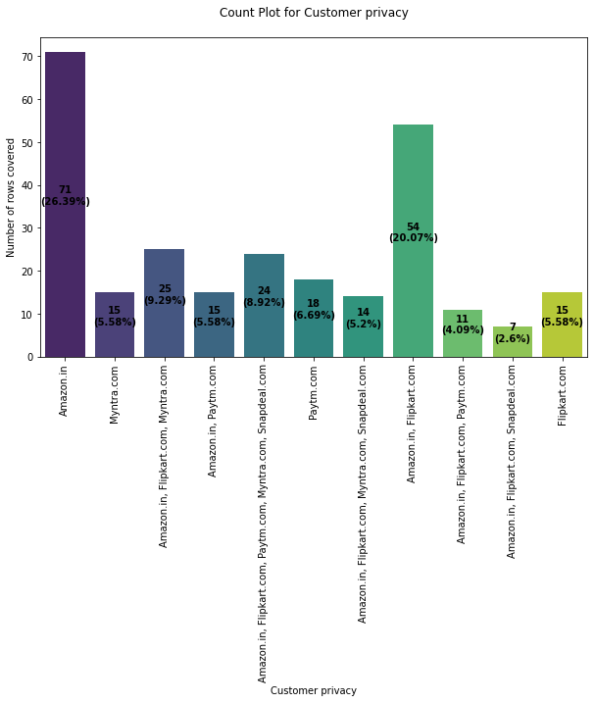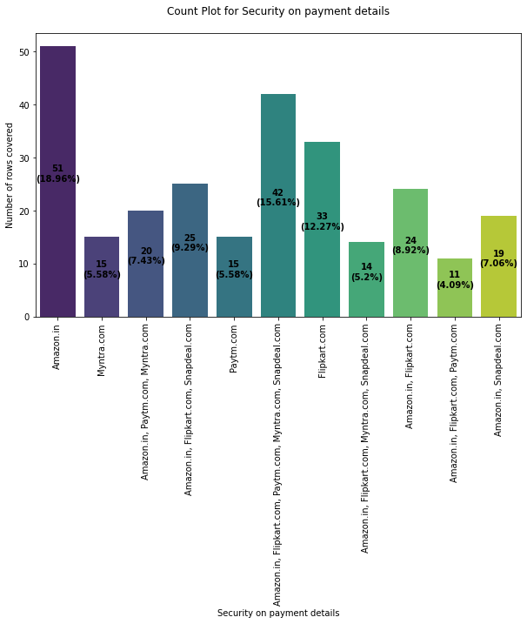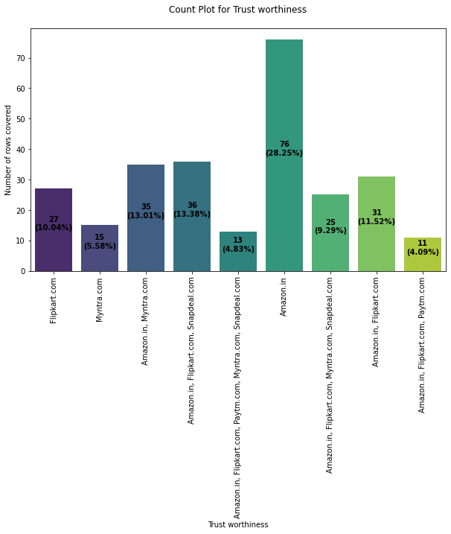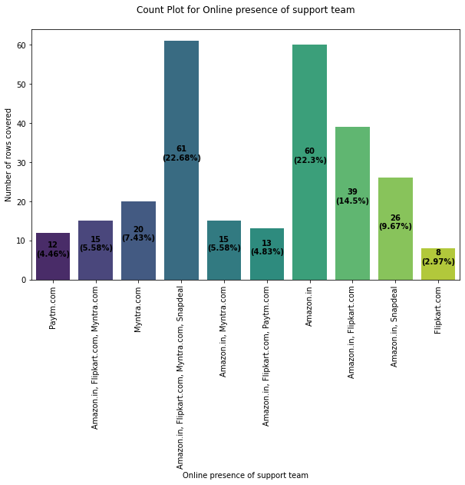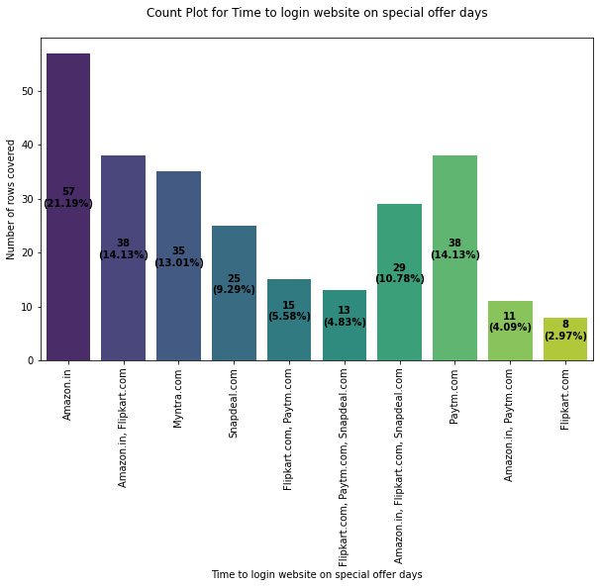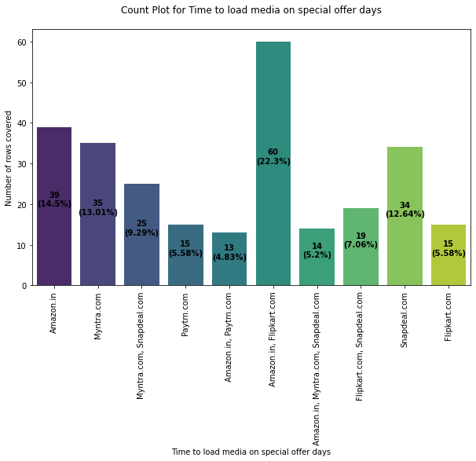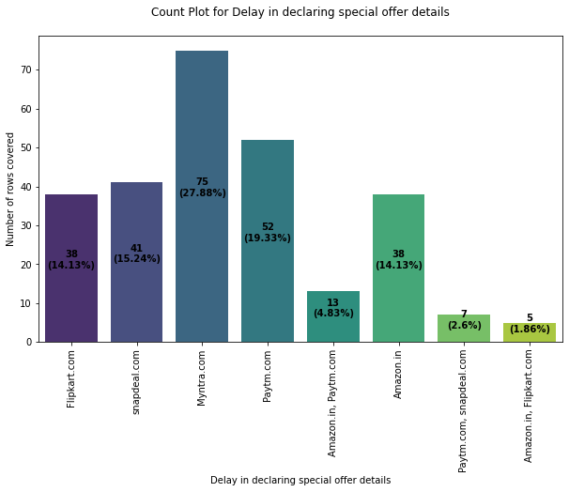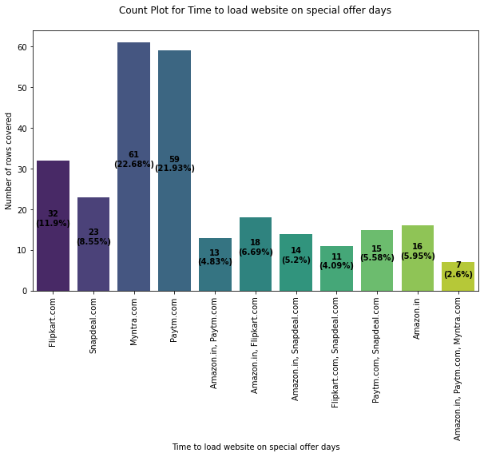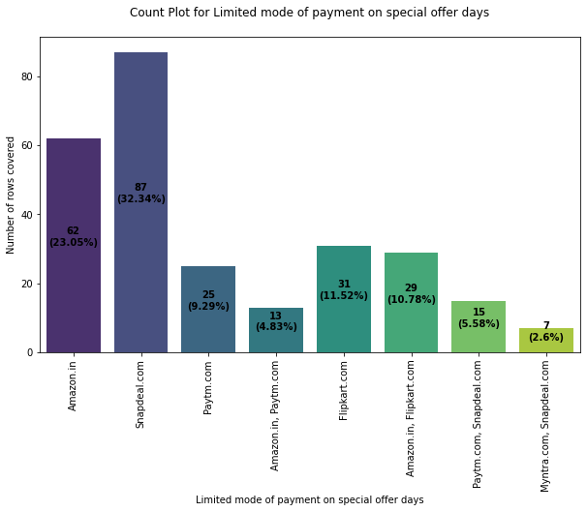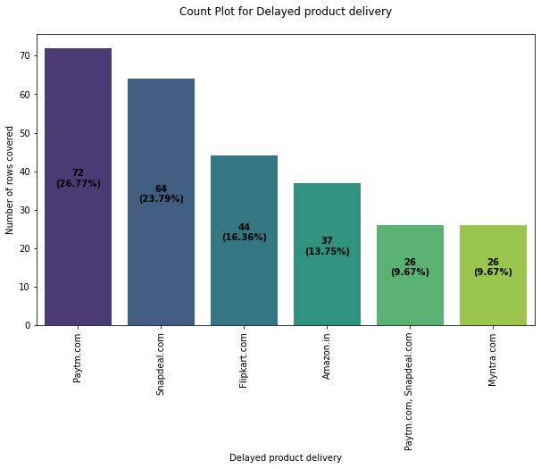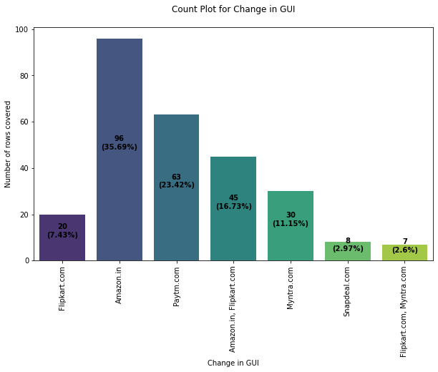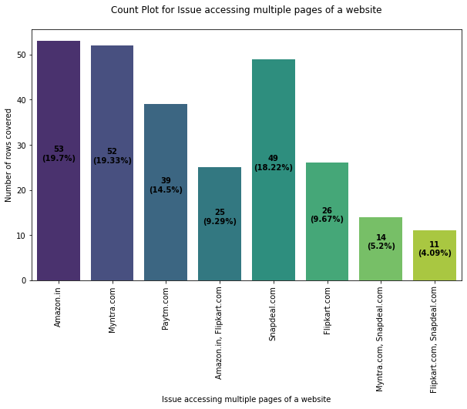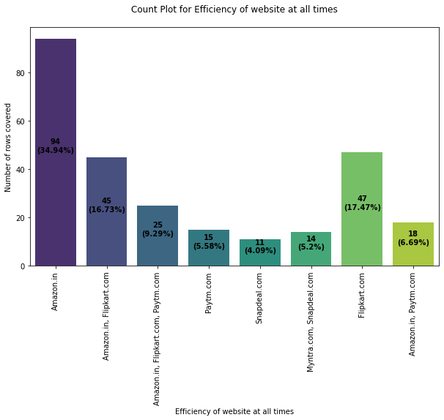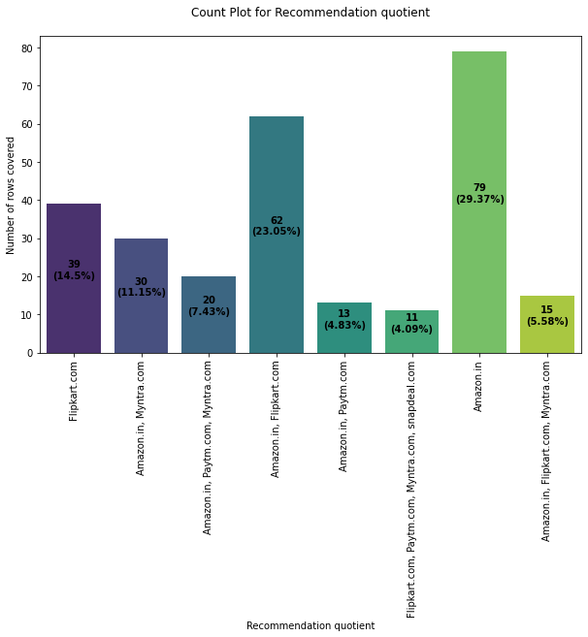

**Bivariate Analysis:**

I performed bivariate analysis using count plots again and changing the hue format. Please refer the code and the outputs in GIF formats below.

Code:

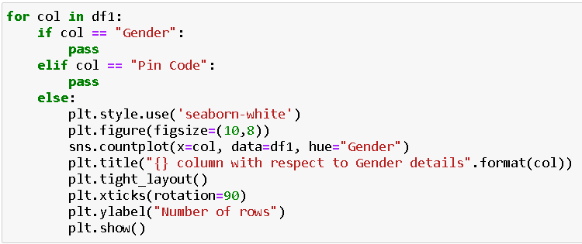

Output:



Code:

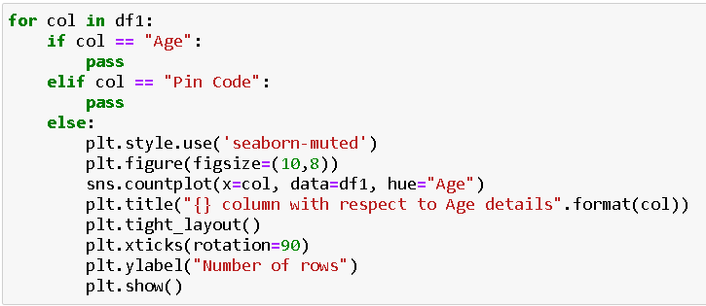

Output:



Code:

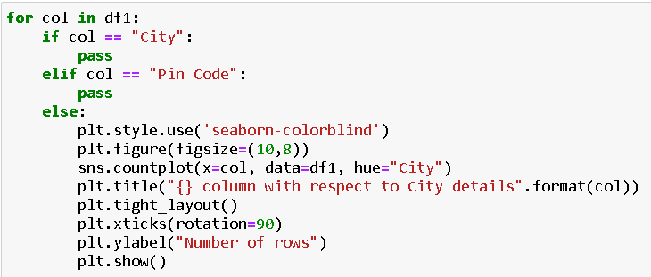

Output:



Then I performed Ordinal Encoding on all the object datatype columns before I could proceed with any kind of multivariate analysis.

Code:

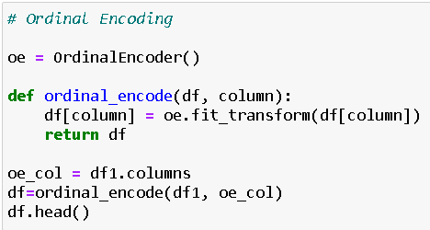

I was able to obtain object datatype conversion to numeric datatype with the help of Ordinal Encoding method.

**Multivariate Analysis:**

For multivariate analysis I made use of Pandas Profiling in my Jupyter Notebook. pandas-profiling is an open-source Python module with which we can quickly do an exploratory data analysis with just a few lines of code. It generates interactive reports in web format that can be presented to any person, even if they don’t know programming.

It also offers report generation for the dataset with lots of features and customizations for the report generated. In short, what pandas-profiling does is save us all the work of visualizing and understanding the distribution of each variable. It generates a report with all the information easily available.

I took a screenshot of the initial output for pandas-profiling however we could scroll through for detailed analysis report on our dataset whilst browsing through different tabs as well. The single line code to get the embedded report is shown below:

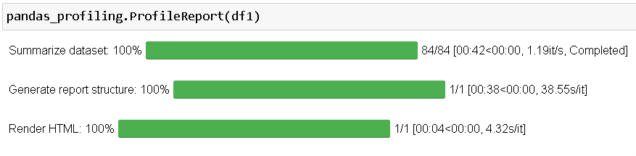

Output:

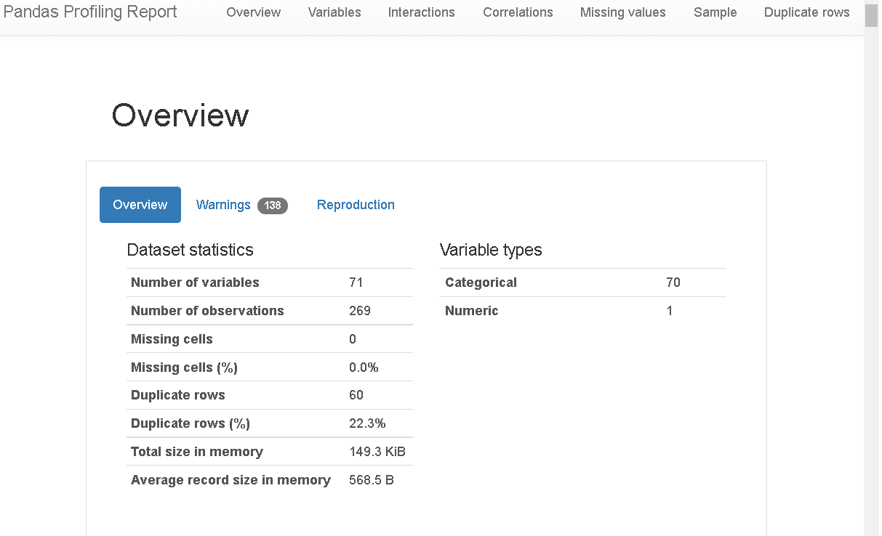

Along with the pandas-profiling method I generated a histogram post encoding all my column values.

Code:

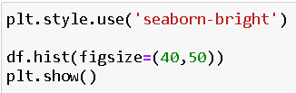

Output:

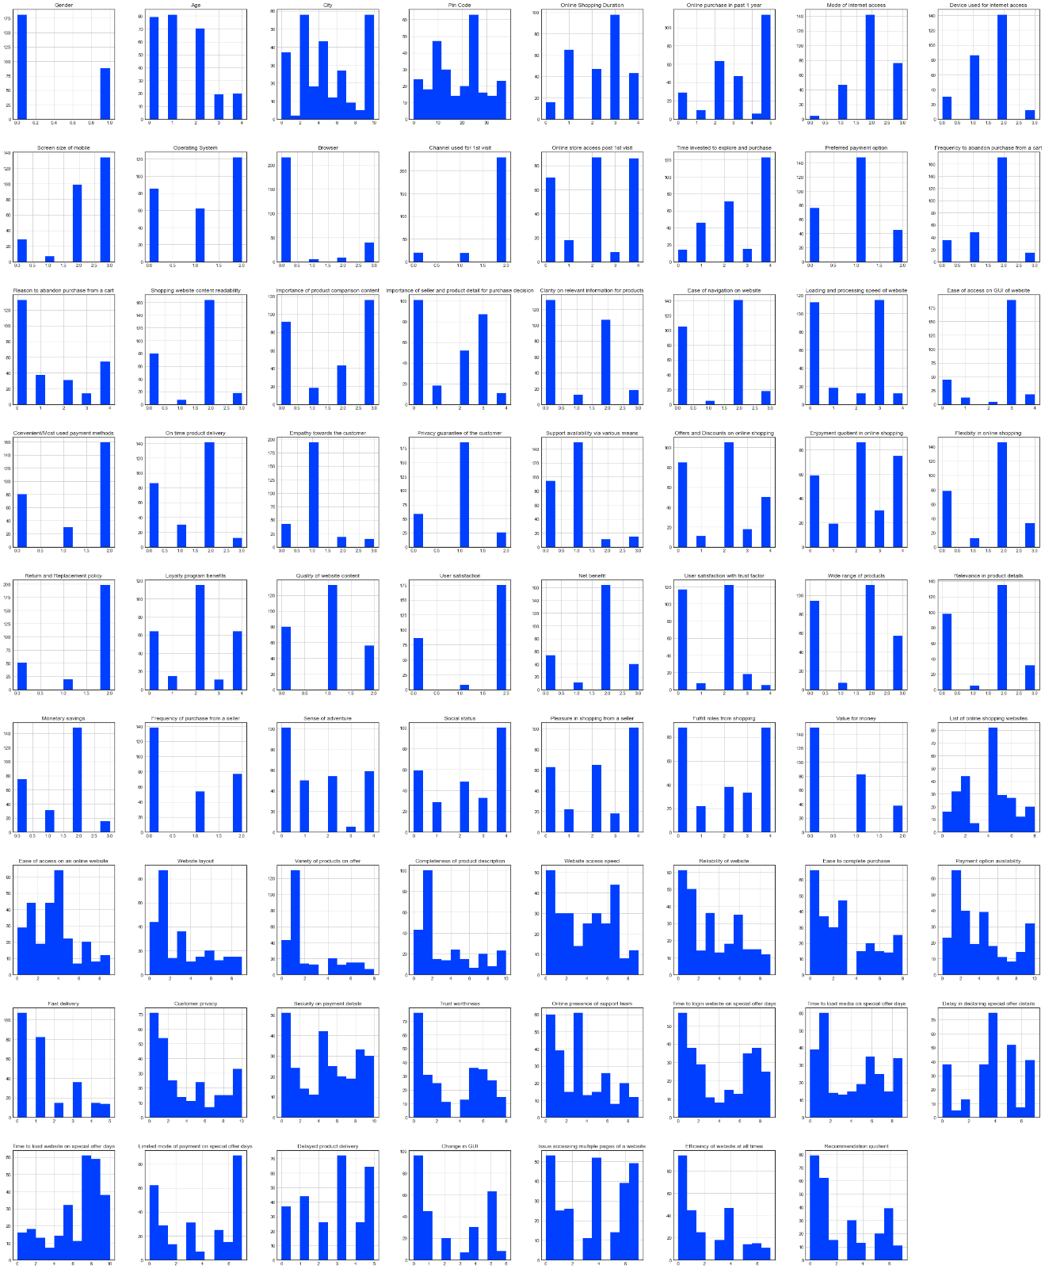

I generated a heatmap using the correlation values between the dataset columns. The correlation details are bifurcated majorly into positive and negative parts.

Positive correlation - A correlation of +1 indicates a perfect positive correlation, meaning that both variables move in the same direction together.

Negative correlation - A correlation of –1 indicates a perfect negative correlation, meaning that as one variable goes up, the other goes down.

Code:

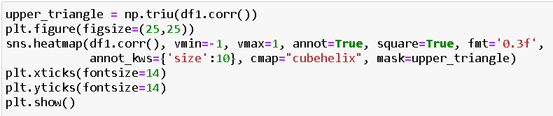

Output:

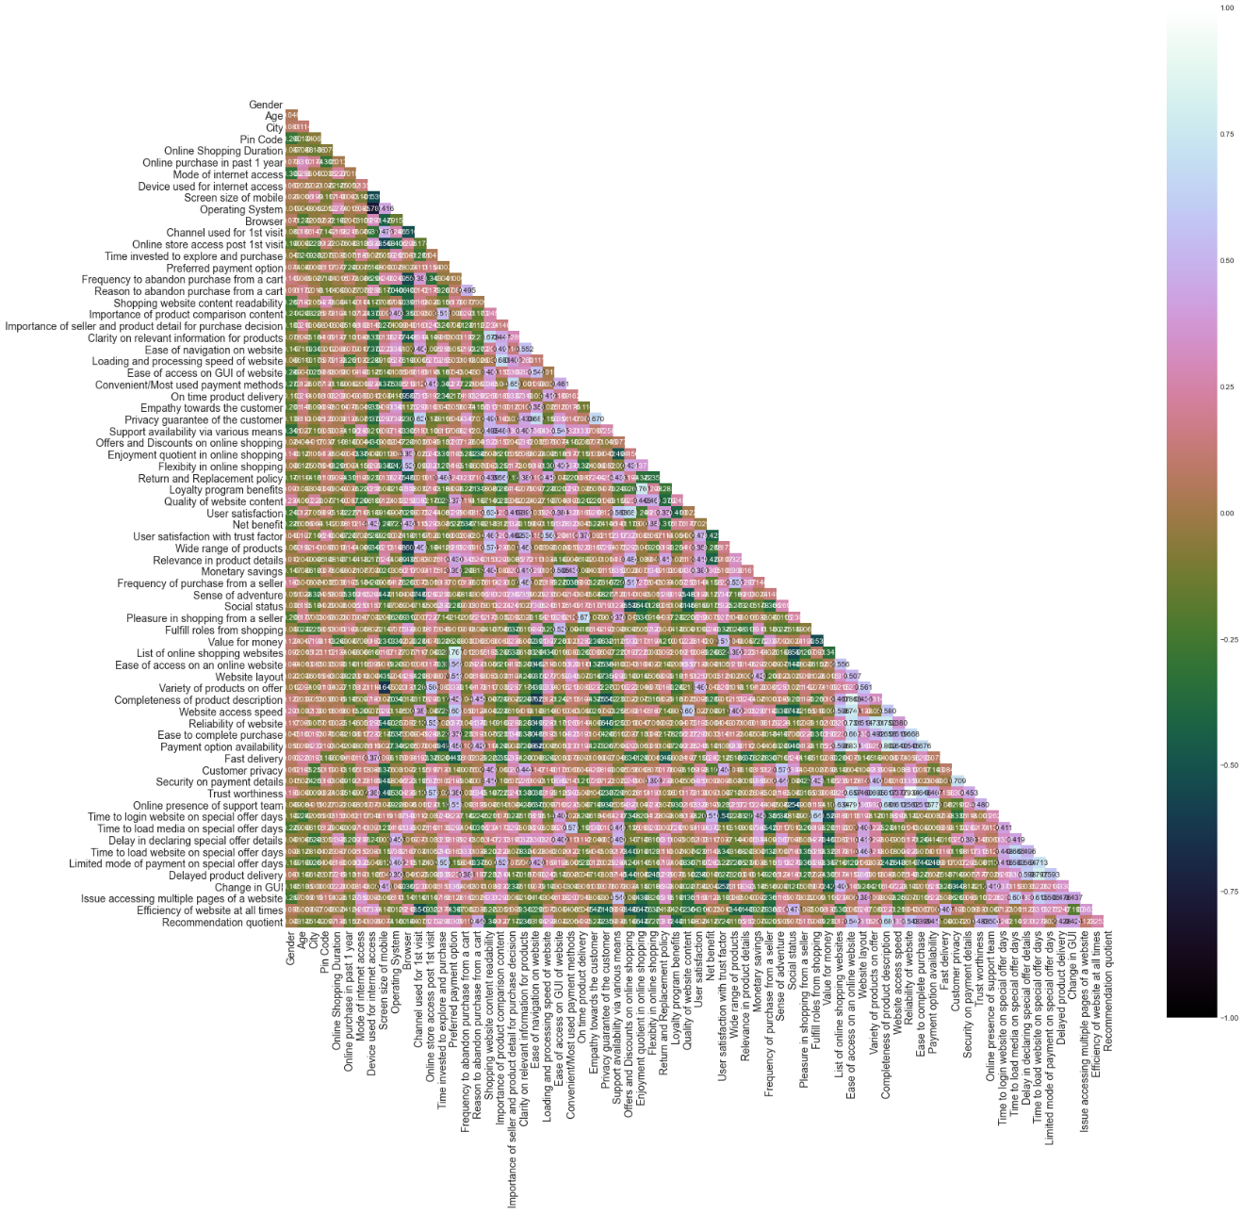

In the above heatmap due to lot of columns we are not able to see the correlation details however we can observe the color-coding details and get a hint that there is no multi collinearity concern between the column values.

Code:

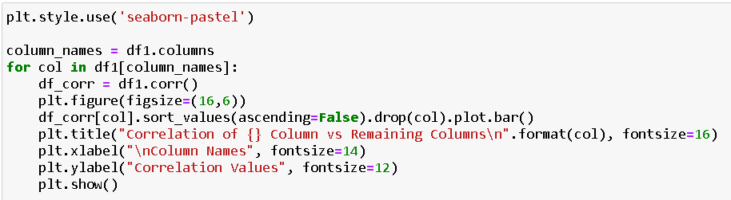

Output:



Since the heatmap was not clear in terms of its values I have generated this bar plot for each column vs remaining column showing the positive and negative correlation data.

##### Inference:

1. **Amazon.com**

To be improved:

* During promotions, try to give a disturbance free shopping experience to customers.
* Give more payment options to customers.
* Try to give price early during promotion.
* Reduce the delivery time of the products.

Positive feedback summary:

* Convenient to use and also a good website for shopping.
* Fast delivery of products.
* Availability of complete information of the products.
* Presence of online assistance through multi-channels.
* Reliable website or app, perceived trustworthiness.

1. **Flipkart.com**

To be improved:

* During promotions, try to give a disturbance free shopping experience to customers.
* Give more payment options to customers.
* Try to give the price early during promotion.
* Reduce the delivery time of the products.
* Flipkart and Amazon almost share the same feedbacks with varying percentages as the only difference.

Positive feedback summary:

* Convenient to use and also a good website for shopping.
* Fast delivery of products.
* Availability of complete information of the products.
* Presence of online assistance through multi-channels.
* Reliable website or app, perceived trustworthiness.
* Wild variety of products to offer.

1. **Myntra.com**

To be improved:

* During promotions, try to give a disturbance free shopping experience to customers.
* Try to give the price early during promotions.
* Reduce the delivery time of the products during promotions.

Positive feedback summary:

* Convenient to use and also a good website.
* Availability of several payment options.
* Faster products delivery.
* Complete information of products available.
* Reliable website or app, perceived trustworthiness.
* Wild variety of product to offer

1. **Paytm.com**

To be improved:

* Reduce the delivery time of the products during promotions.
* Try to give the price early during promotion.
* During promotions, try to give a disturbance free shopping experience to customers.
* Late declaration of price and discounts.
* Frequent disturbance is occurring while moving from one page to another.

Positive feedback summary:

* Convenient to use and a good website.
* Quickness to complete a purchase.
* About 64% of the customers feel that either web or app is reliable.
* Around 20% of the customers believe that Paytm has a wild variety of products on offer.

1. **Snapdeal.com**

To be improved:

* Reduce the delivery time of the products during promotions.
* Try to give the price early during promotion.
* During promotions, try to give a disturbance free shopping experience to customers.
* Late declaration of price and discounts.
* No one has expressed to recommend Snapdeal to a contact as it has the most negative feedbacks among all other websites.

Positive feedback summary:

* Convenient to use.
* 54% of the customers are happy about the availability of financial information security.

##### **Conclusion:**

The first 47 characteristics, based on general observations, give insights into how the e-tailer is helping and expanding depending on client suggestions. The data revealed which CITY, PIN CODE, AGE, and other variables were utilized most frequently on the web platform. It also revealed that some factors are given less weight in contributing to the success of an e-commerce store; as a result, we could eliminate those factors while keeping all of the important ones, as well as improve on some of the factors that influence online customers' repeat purchase intentions.

Aside from the first 47 elements, the remaining attributes demonstrated which online platform has been used more frequently based on success factors. According to the case study for client activation and retention, Amazon is the most dependable and has met the customer's needs. Data indicated that Flipkart was utilized more for online buying after Amazon.

According to a case study of Indian e-commerce clients, Amazon and Flipkart are the most frequently utilized for online shopping and are the most frequently suggested by friends. So, based on the research findings, Amazon and Flipkart are e-commerce platforms that combine utilitarian and hedonistic values to favorably influence repeat purchase intention (loyalty).

##### **Future Work:**

• I'll have to do some preparation on the data, such as utilizing scaling algorithms.

• I'm not going to bother about reducing outliers or skewness because the dataset contains largely categorical data.

• Unsupervised machine learning models must be built.

• Will need to double-check the specifics of the clustering or association method that may be employed on the dataset.

K-means clustering, k-nearest neighbors for unsupervised machine learning, hierarchal clustering, apriorism algorithm, and neural networks are some of the methods I plan to work on.